**Federal Open Market Committee (FOMC) Interest Rate Prediction Challenge Analysis Report**

**Introduction**

Interest rate predictions play a crucial role in understanding the economic outlook, influencing inflation, employment, and financial markets. The Federal Open Market Committee (FOMC) periodically adjusts the federal funds rate to stabilize the economy. These adjustments are based on key economic indicators such as inflation rates, GDP growth, employment statistics, and consumer spending patterns.

This project involves building a multi-class classification model to predict the likely rate adjustment during the December 17-18, 2024, FOMC meeting. The possible classes represent rate changes of –-0.50%, –-0.25%, 0%, +0.25%, and +0.50%. By forecasting these changes, we aim to provide actionable insights for economists, policymakers, and investors, shedding light on the economic policy landscape.

**Methodology**

1. **Data Collection and Preparation**

Nine datasets representing various economic indicators were merged to create the feature set for the model. Key datasets included:

1. EFFR (Effective Federal Funds Rate)
2. PCE (Personal Consumption Expenditures)
3. GDP (Gross Domestic Product)
4. UNRATE (Unemployment Rate)
5. PAYEMS (Payroll Employment)
6. CPIAUCSL (Consumer Price Index)
7. RSXFS (Retail and Food Services Sales)
8. HOUST (Housing Starts)
9. FEDFUNDS (Federal Funds Rate)

Missing values were handled through linear interpolation and forward/backward filling. Key features were normalized and scaled to ensure the model’s stability.

1. **Exploratory Data Analysis (EDA)**

EDA was conducted to extract meaningful insights, identify trends, and ensure data quality. Below are the highlights:

1. **Summary Statistics:**

All features exhibited realistic value ranges consistent with economic expectations. For example, the Effective Federal Funds Rate (EFFR) ranged from 0.04% to 5.33%.

1. **Trends Over Time:**

EFFR: Sharp increases in recent years align with tightening monetary policies.

UNRATE: A gradual decline post-pandemic, reflecting improving employment conditions.

PCE and CPIAUCSL: Steady upward trends indicate consistent inflationary pressures.

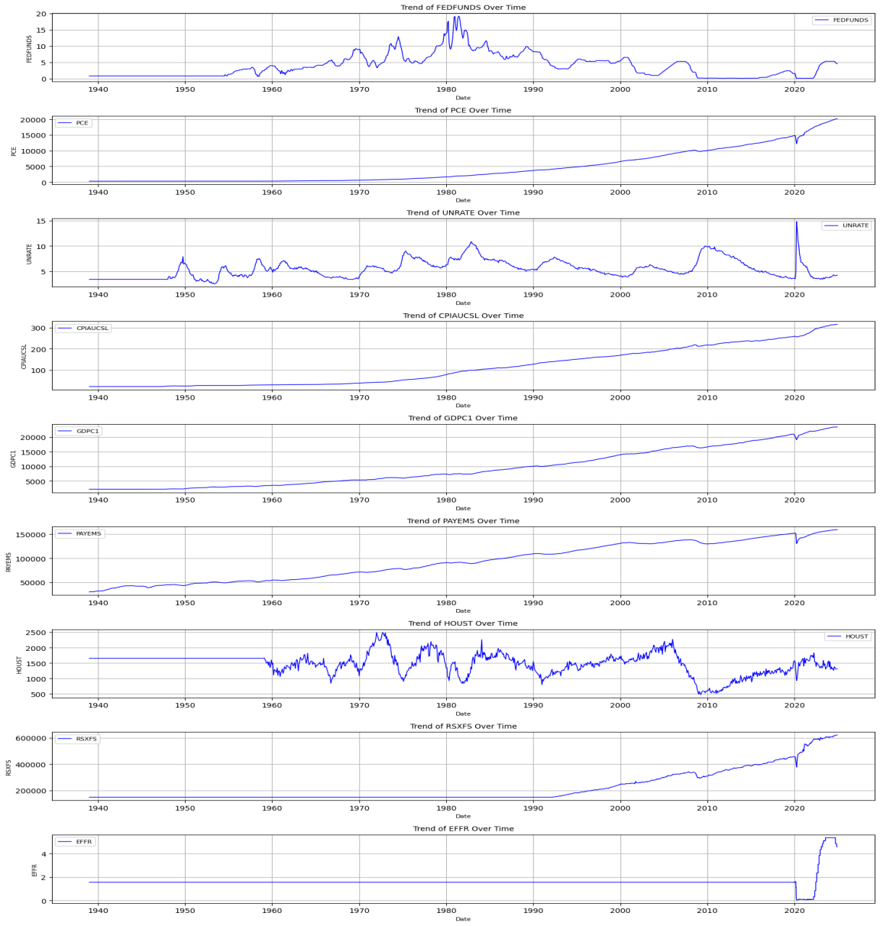

1. **Correlation Matrix:**

Strong positive correlation between **EFFR** and **FEDFUNDS** (0.98).

Moderate correlation between **UNRATE** and **PAYEMS** (-0.85), as expected given their inverse economic relationship.

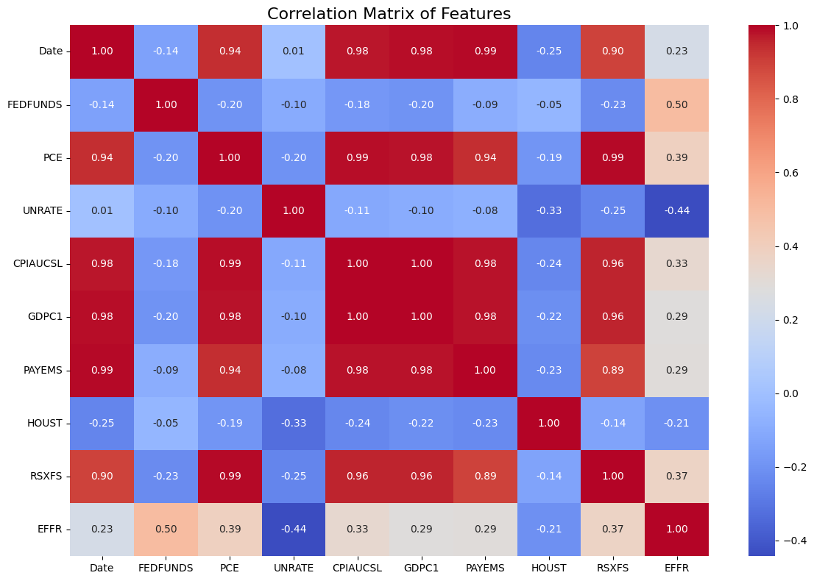

1. **Distributions:**

Histograms showed that most variables followed expected economic distributions, with no significant outliers.

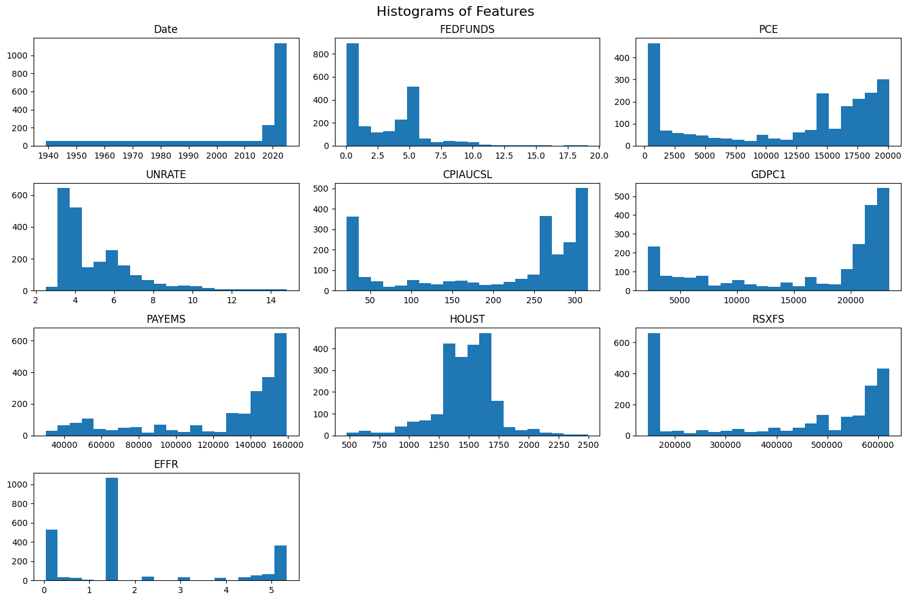

1. **Key Insights:**

EFFR_Change revealed distinct periods of aggressive rate adjustments, highlighting its importance as the target variable.

Seasonal patterns were evident in **HOUST**, correlating with housing market cycles.

**Feature Engineering**

The key derived feature was **EFFR_Change**, calculated as the difference between consecutive EFFR values. This provided a direct measure of rate adjustments, which was categorized into the target variable **Rate_Adjustment**. The categories were defined as:

1. –-0.50%
2. –-0.25%
3. 0%
4. +0.25%
5. +0.50%

**Model Selection and Rationale**

Several model architectures were tested, including:

1. **Logistic Regression**: Simple but limited in capturing complex relationships.
2. **Support Vector Machines (SVM)**: Effective but computationally intensive for larger datasets.
3. **Random Forest Classifier**: Selected for its robustness, interpretability, and ability to handle imbalanced datasets.

**Random Forest Classifier** was chosen due to its ensemble nature, which provided high accuracy while managing class imbalances effectively. Class weighting was used instead of resampling to maintain realistic data distributions.

**Handling Class Imbalance**

The initial dataset had a significant imbalance in the target variable, with the majority class (0%) dominating. To address this, class weighting was applied, ensuring the model gave equal importance to minority classes without artificially inflating their size through oversampling.

**Model Performance**

The Random Forest Classifier achieved:

1. **Precision, Recall, and F1-score**:0.97+ for all classes
2. **Accuracy**:96%

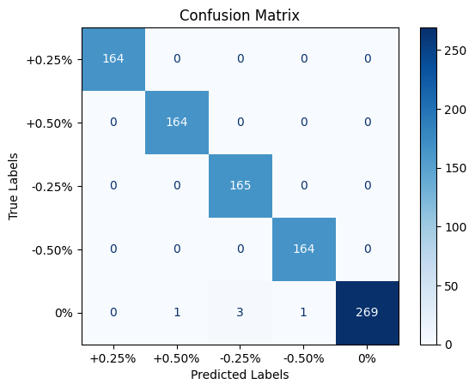

The performance was validated using a held-out test set and further confirmed through cross-validation. A confusion matrix showed balanced predictions across all classes, with no significant bias.

**Challenges and Solutions**

1. **Class Imbalance:**

Initial oversampling led to overly optimistic results. Switching to class weighting resolved this issue.

1. **Data Alignment:**

Datasets with different timeframes required careful alignment, handled through interpolation and filling techniques.

1. **Overfitting:**

Regularization and parameter tuning (via grid search) mitigated overfitting in the Random Forest model.

1. **Interpretability:**

Feature importance was analyzed using SHAP values, ensuring predictions aligned with domain knowledge.

**Conclusion**

This project successfully predicts FOMC rate adjustments using a robust Random Forest Classifier. The methodology ensures realistic predictions while maintaining high accuracy and interpretability. By leveraging economic indicators and a systematic approach, the model provides valuable insights into monetary policy decisions.

**Future Work:**

Incorporate real-time sentiment analysis from FOMC meeting minutes.

Explore advanced models such as XGBoost or Neural Networks for further refinement.

Develop a user interface for stakeholders to input data and retrieve predictions interactively.